**RPG III**

BASIC OPERATIONS

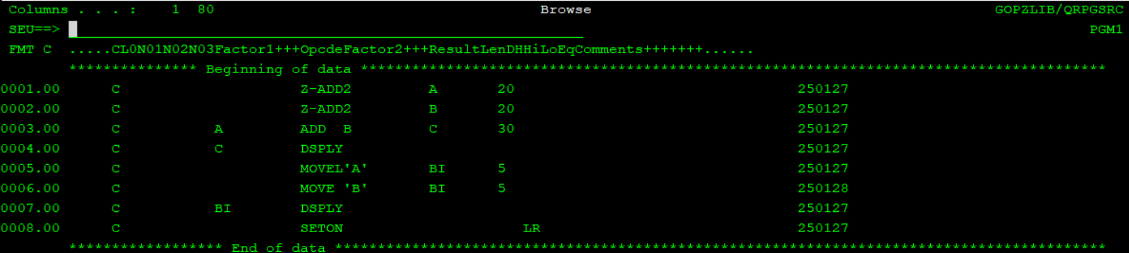

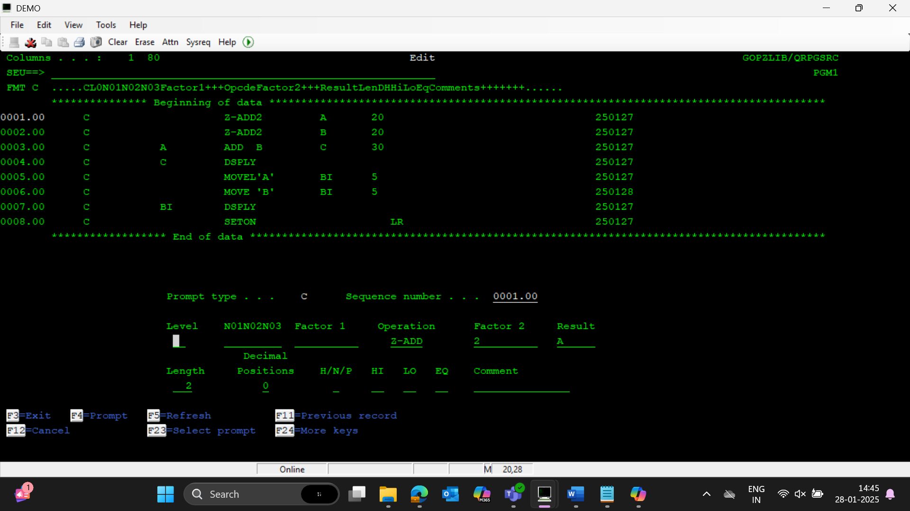

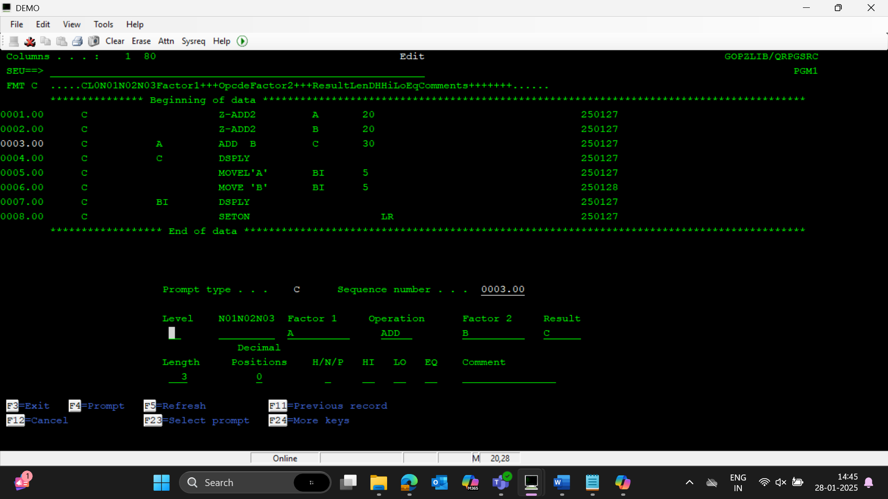

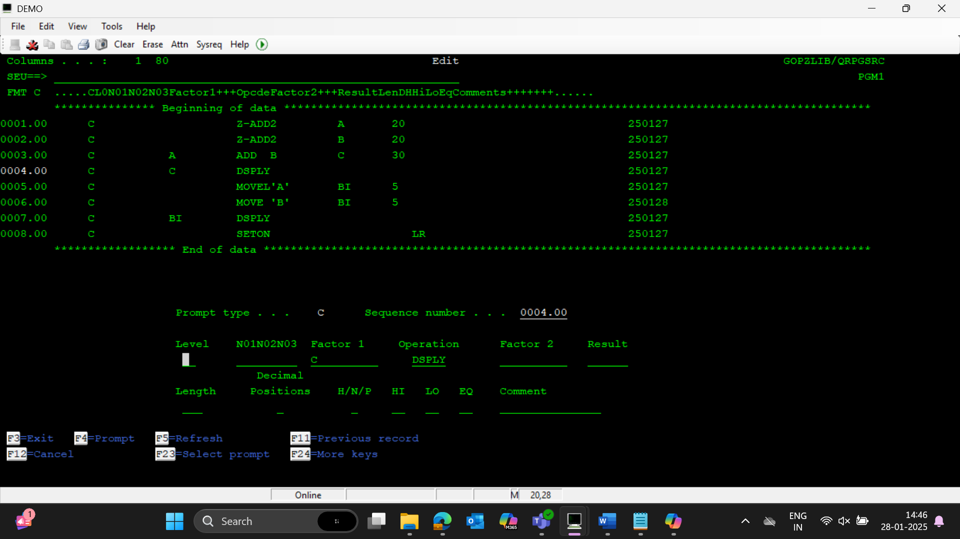

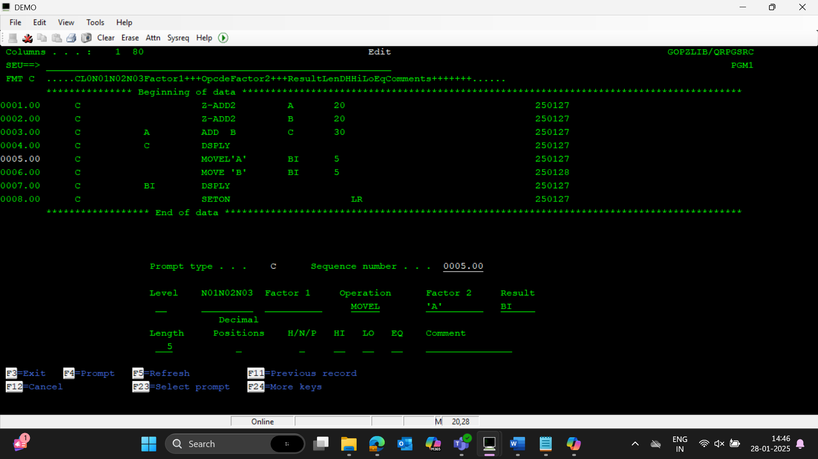

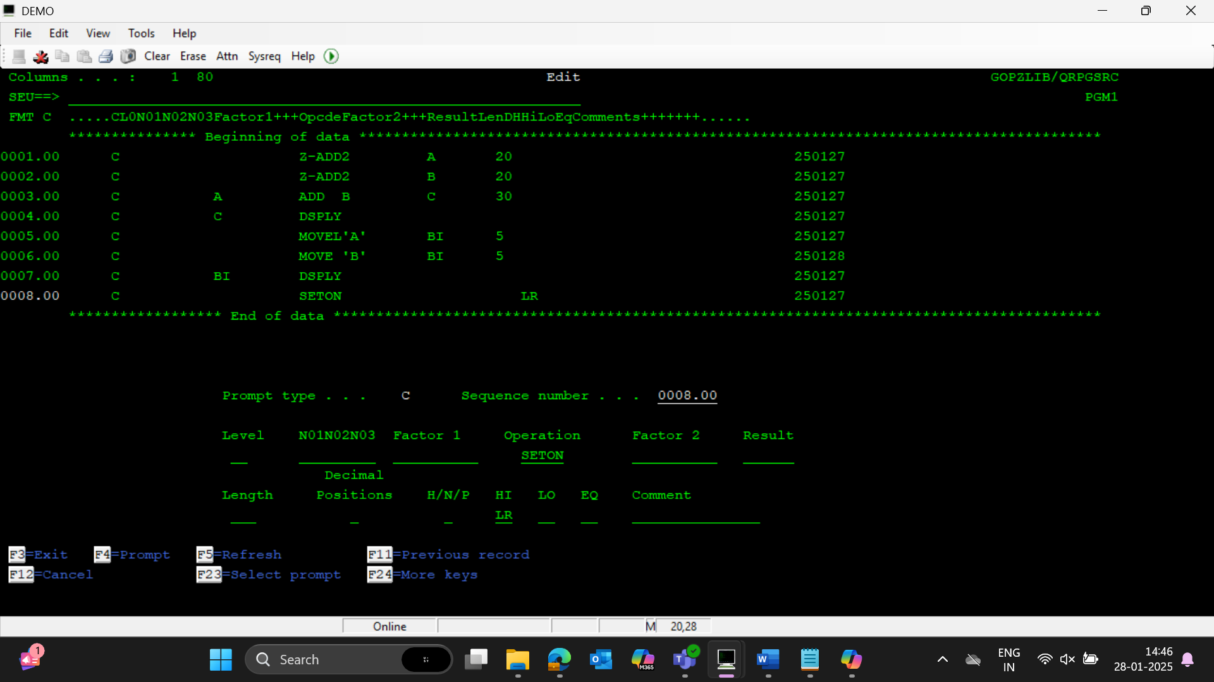

READALL FROM FILE

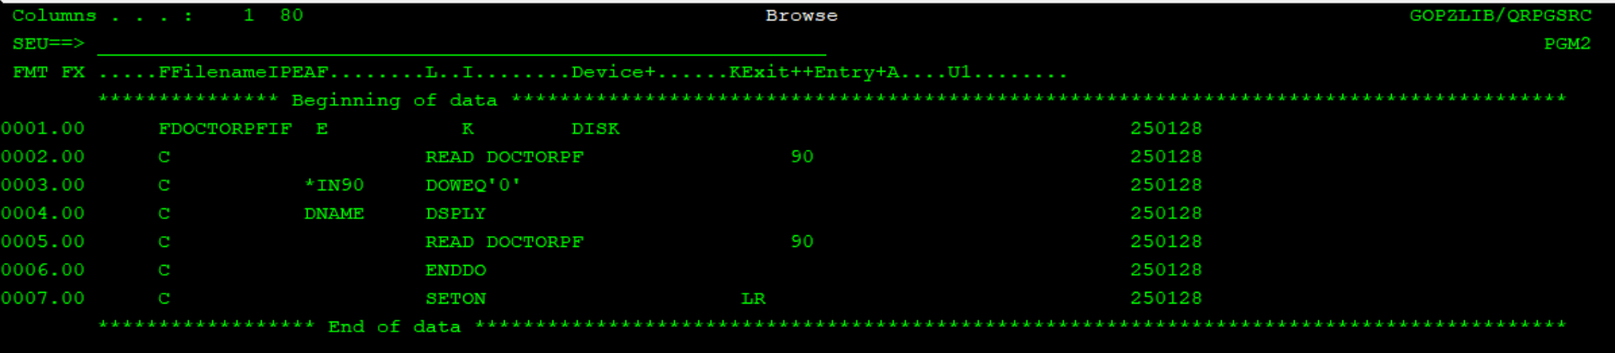

All fieldnames in the specified file should be of length less than 6

CHAIN-IF FILE

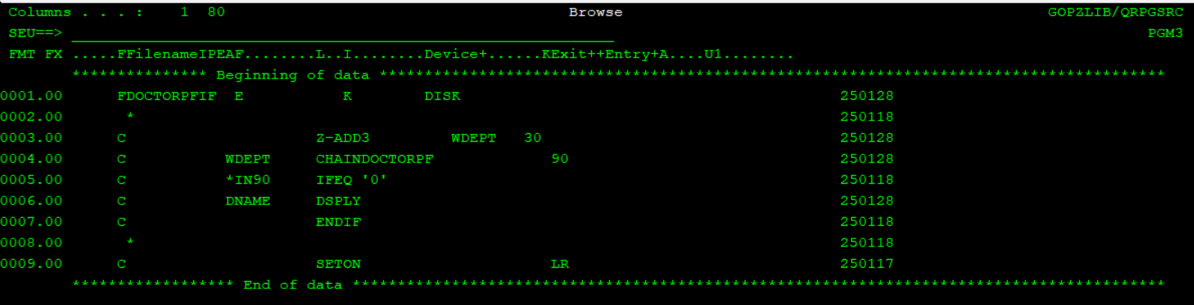

READE IN FILES

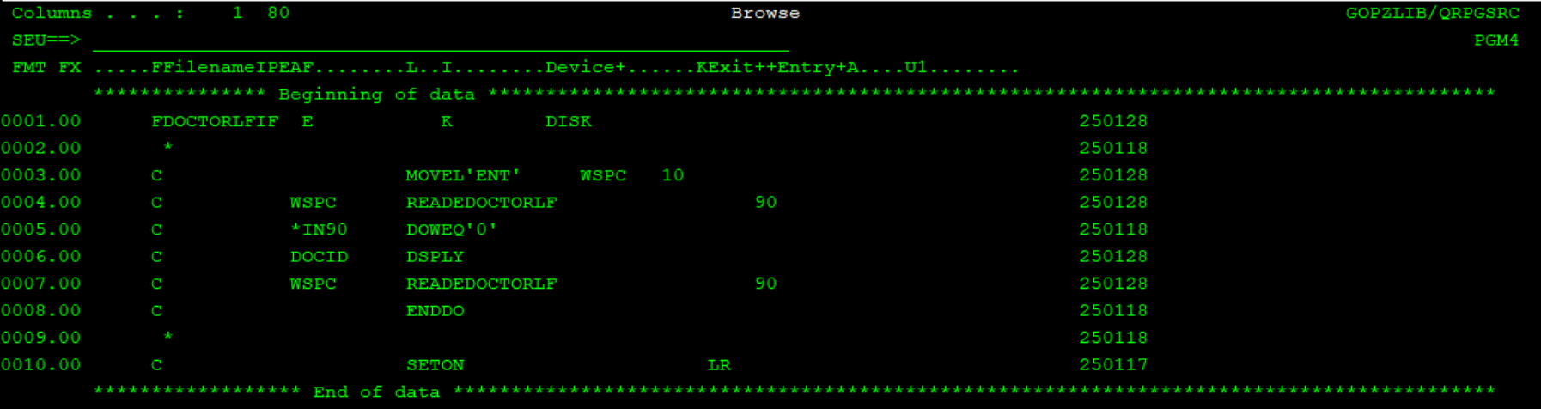

UPDATE

